**Selenium Grid? What?**

**Selenium Grid** is a part of the Selenium Suite that specializes in running multiple tests across different browsers, operating systems, and machines in parallel.

Selenium Grid uses a hub-node concept where you only run the test on a single machine called a **hub**, but the execution will be done by different machines called **nodes**.

Now we setup the Hub and Nodes Step by Step

**HUB**

1. First make sure java is Installed on the Hub machine or the machine which you want to make Hub machine 

Check java is installed using command in command prompt

java --version

1. Create a folder in C drive, then download the latest Selenium Server Standalone Jar file from google in the folder
2. Then create a text file wit the below data – Icon

   Description automatically generated

cd C:\Selenium_Server  
java -jar selenium-server-4.21.0.jar hub

1. Convert text file into batch file, by renaming extension.txt into .bat, once convert the file looks like  Icon

   Description automatically generated
2. Then execute the file, the server will be started Icon

   Description automatically generated

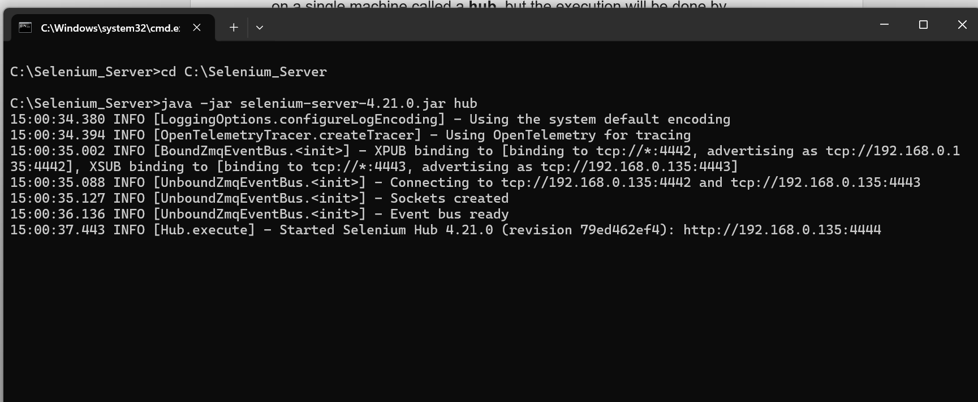

As per screenshot, the hub url is – <http://192.168.0.135:4444>

1. Now we check using the URL that hub is up ,

As we are not registered any nodes, we can see below message -

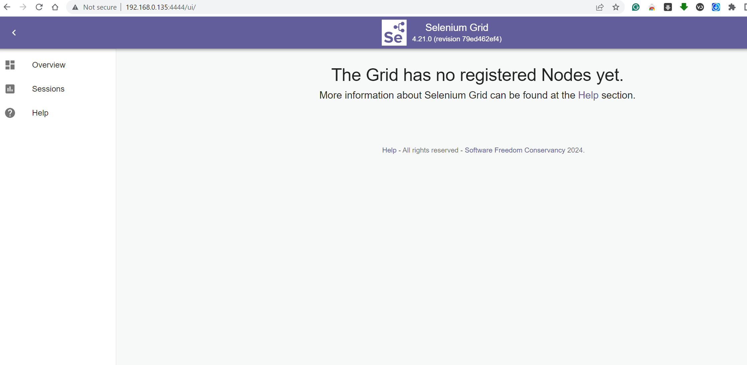

**NODE**

1. First make sure java is Installed on the Node machine or the machine which you want to make Node machine Icon

   Description automatically generated

Check java is installed using command in command prompt

java --version

1. Create a folder, then download the latest Selenium Server Standalone Jar file from google in the folderIcon

   Description automatically generated
2. Create a folder in C drive and Download the drivers

1. Then create a text file wit the below data – Icon

   Description automatically generated

cd C:\Selenium_Node

java -jar selenium-server-4.21.0.jar node --port 8888 --hub http://192.168.0.135:4444/grid/register

5.Convert text file into batch file, by renaming extension.txt into .bat,

1. Then execute the file, the node will be started Icon

   Description automatically generated

**Selenium Grid**

Now check the Node is connected to hub using selenium grid console url

<http://192.168.0.135:4444/ui/>

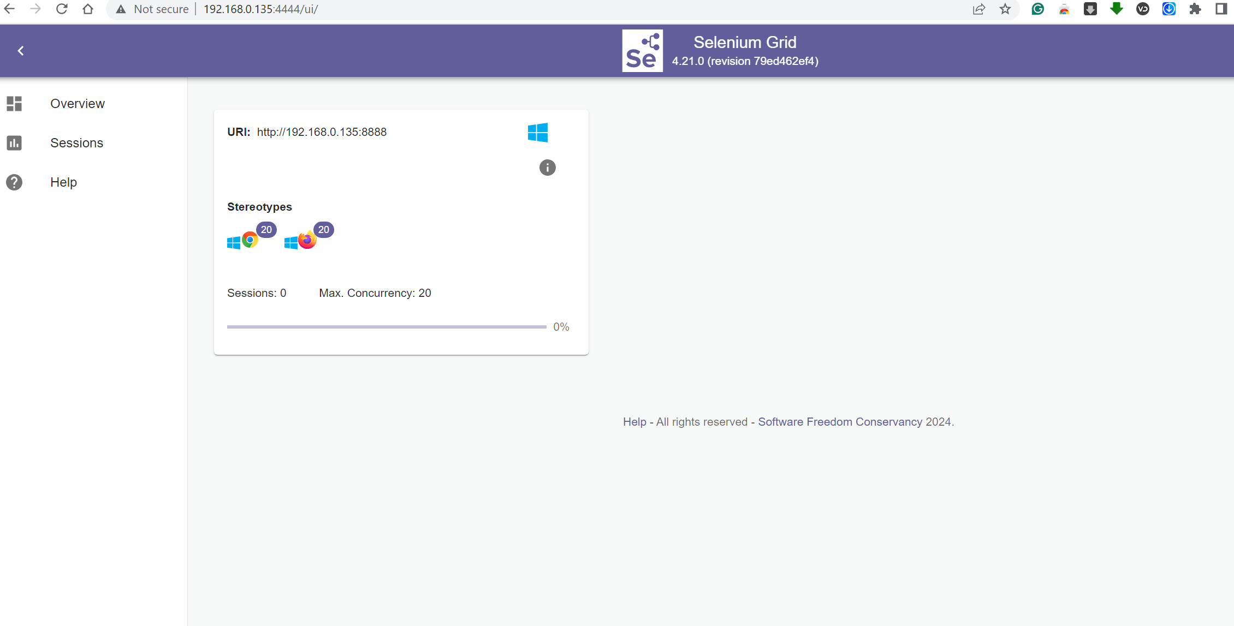

Execute the Scripts from Jenkins on hub by mentioning the grid hub url

-U --settings src/test/resources/settings.xml clean install -fae -o -D "job.number=${BUILD_NUMBER}" -D "job.name=${JOB_NAME}" -D "grid.hub.url=<http://192.168.0.135:4444/ui/>" -Dgroups=${groups} -DSelect_Plan_Group="${Select_Plan_Group}" -Denvironment=${environment}